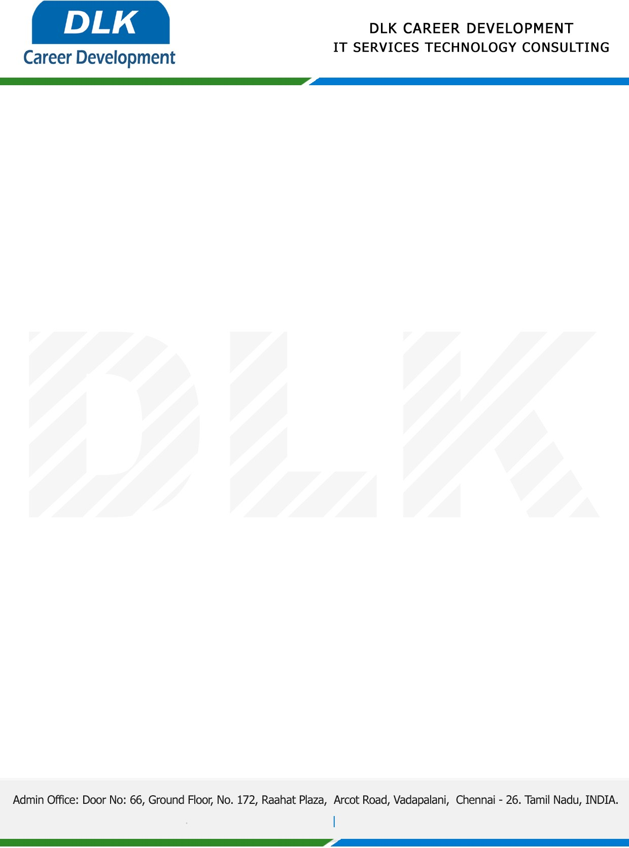

Date: 18/ January/ 2023

**To**

Department of [B.SC](http://M.SC) ([Computer Science),](https://www.cseindia.org/)

Head of Department,

Jaya Arakkonam Arts and Science College.

**Sub: Letter of Project Acceptance**

This is to certify that **MS Harini A (REG NO: 30220U09001)** that final year student of has accepted his Project Work duration from **20 January 2023 to 19 February 2023** under the domain **“Python”.** During the internship, all information and data collected from you should be kept confidential.

**Topic:** **blood cell counting using OpenCV python**

We appreciate your interest in **DLK CAREER DEVELOPMENT**

